**How to create a morphologically realistic neuron model using Cell Builder**

**Ben Latimer – based on the tutorial at https://www.neuron.yale.edu/neuron/static/docs/cbtut/pt3d/outline.html**

**Step 1 – Download cell from NeuroMorpho.org**

Neuromorpho.org is a database of neuron reconstructions from a plethora of species and brain regions. They are in varying degrees of quality/completeness. A PV Interneuron from the rodent amygdala has been downloaded for you and placed into the DetailedSingleCell folder. Feel free to browse the site for other neurons of interest but use the PV cell to complete this project.

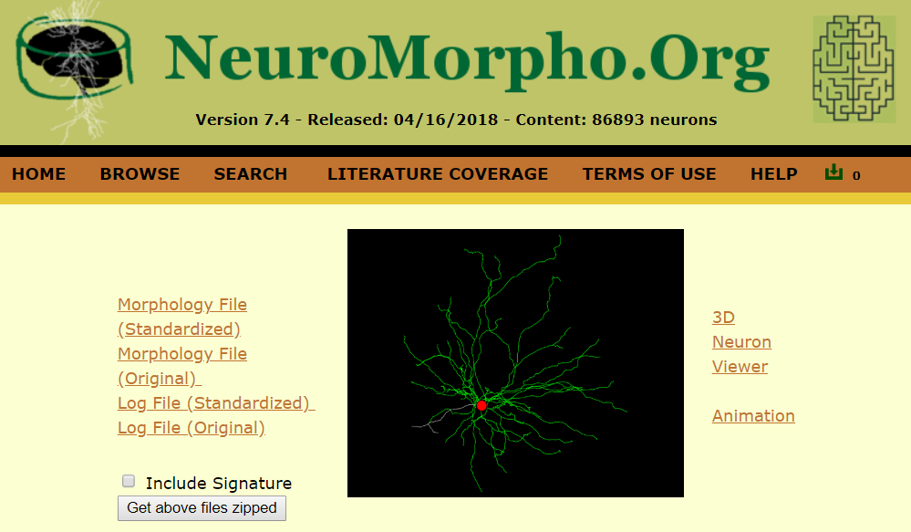

**Step 2 – Import the cell geometry into NEURON**

Open NEURON (note these instructions are for NEURON 7.5) by typing *nrngui* at the command prompt (Mac OS/Linux) or bash shell (Windows). You’ll see the familiar NEURON GUI. Click Tools > Miscellaneous > Import 3D.

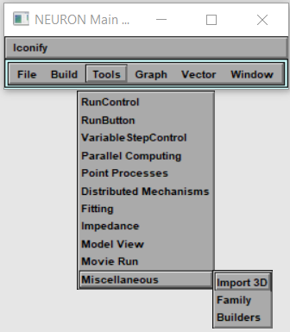

Click the box that says “choose a file” and navigate to the .swc file (PV140912-02.CNG.swc).

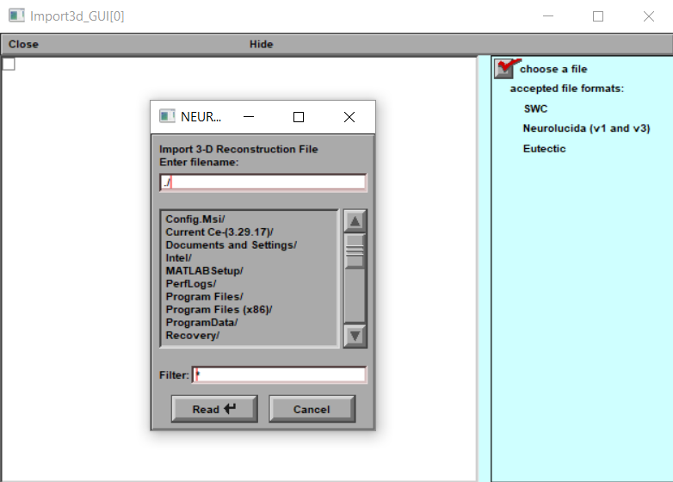

You may see this message:

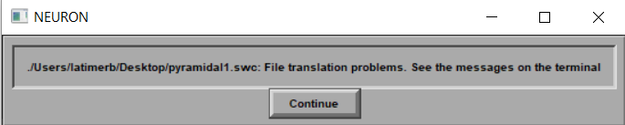

Typically, this is just because there are some comments in the .swc file that couldn’t be interpreted. No need to worry but check out the messages in the terminal anyway.

Now you’ve got a cell! Click Export > CellBuilder

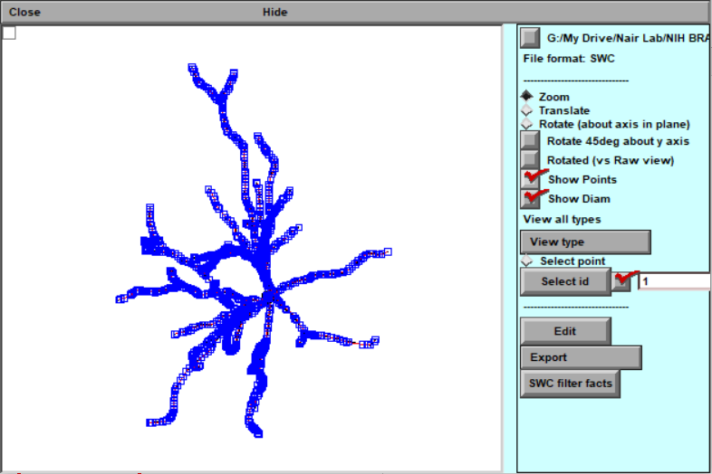

**Step 3 – Make a model of the cell**

Now that we’ve imported our cell from the reconstruction, we’re ready to make a model. Luckily, CellBuilder makes the geometry part easy:

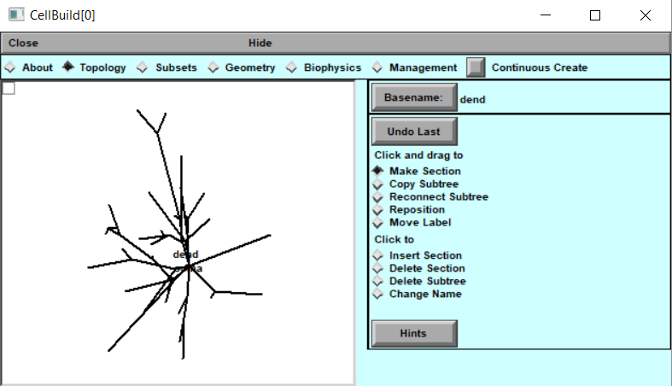

What happened to our beautiful geometry?! It’s still there. Just click “Continuous Create” and go to Graph > Shape Plot in the NEURON main menu.

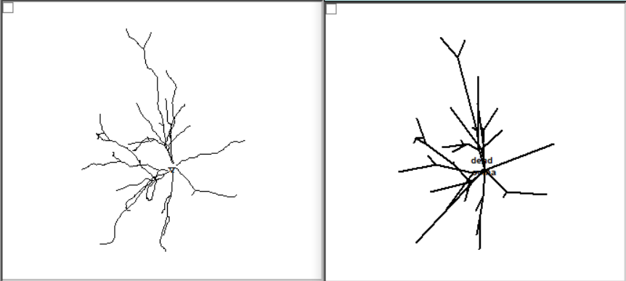

The CellBuilder takes the shortest route between the endpoints of each section when it shows it on the screen but all of the complex geometry is still available.

It’ll be up to us to put in the channels. This is a good time to mention that at any time if you want to save your “session” so you can come back to it later, you have that option. Just click File > Save Session. It’s a best practice to go ahead and save the “bare bones” session (before you embark on the biophysics) so that if you mess up later, you can come back to it.

**Step 4 – Add some biophysics**

At this point, all we have is the skeleton of a cell. We need to specify what channels are involved and the size of the sections. Custom channels such as kdrinter, nainter, and leakinter have been place in the project directory. The regular Hodgkin-Huxley sodium and potassium channels will also be available.

Throughout the process, you’ll use the “Specify Strategy” button to toggle between the list of sections and the values for those sections.

We’re finally ready to add some channels. We’ll add the Na+, K+, and leak channels to the soma and make the dendrites passive.

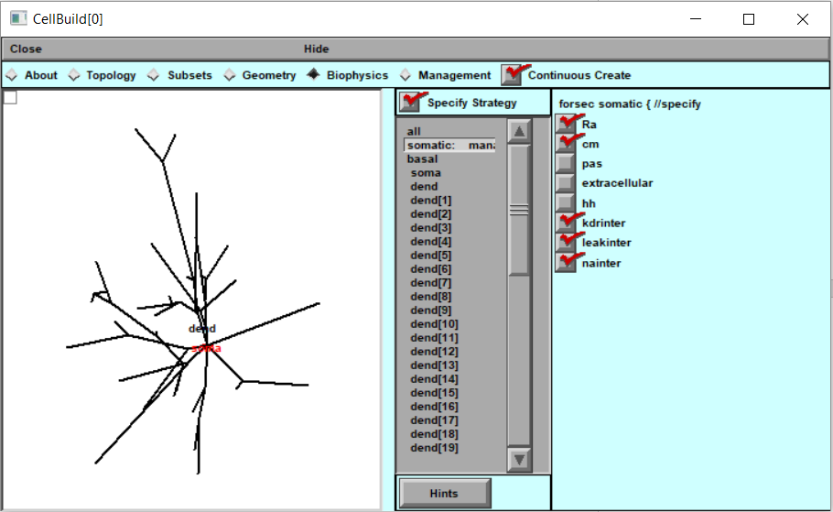

Select Ra, cm, kdrinter, leakinter, and nainter. Then unclick “Specify Strategy”. Now you can go through and specify the various conductances, capacitances, resistances, etc. Add the leak channel to the “basal” category, which is all the dendrite sections.

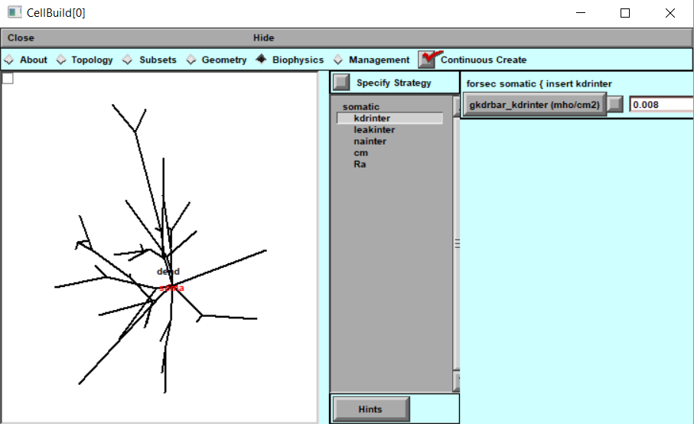

**Step 5 – Put your new cell in a current clamp**

You’ve added all the biophysics you think will be necessary to make your cell behave like you want. Now it’s time to see if it really does. Close NEURON and double-click IClamprig.ses. You’ll see some boxes like this:

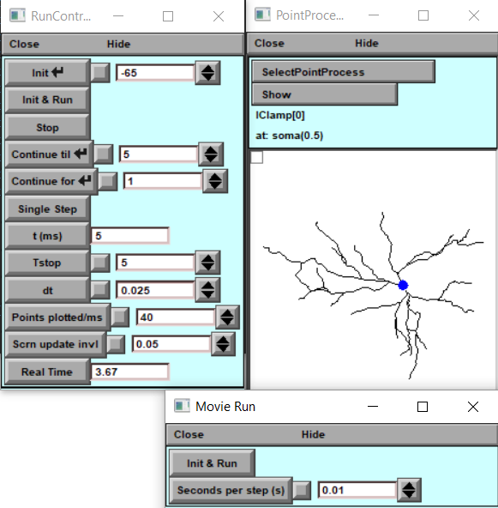

At this point, you will need to “tune” the cell to match experimental data. Many of the parameters are unknown or may be in a range so they can be changed within reason to match the behavior seen in vitro. Start with the values you used for the cell with simple geometry.

**As with project 1a, your goal is to match the passive properties (input resistance, time constant, and resting membrane potential) then match the firing properties (generate an FIR curve).**

To export the cell for use in a template, in CellBuilder click Management > Cell Type. Click Classname and give your cell type a name (i.e. PyramidaltypeA, axoaxoniccell, etc.). Then click “Save hoc code in file”.